Kathleen Cannon
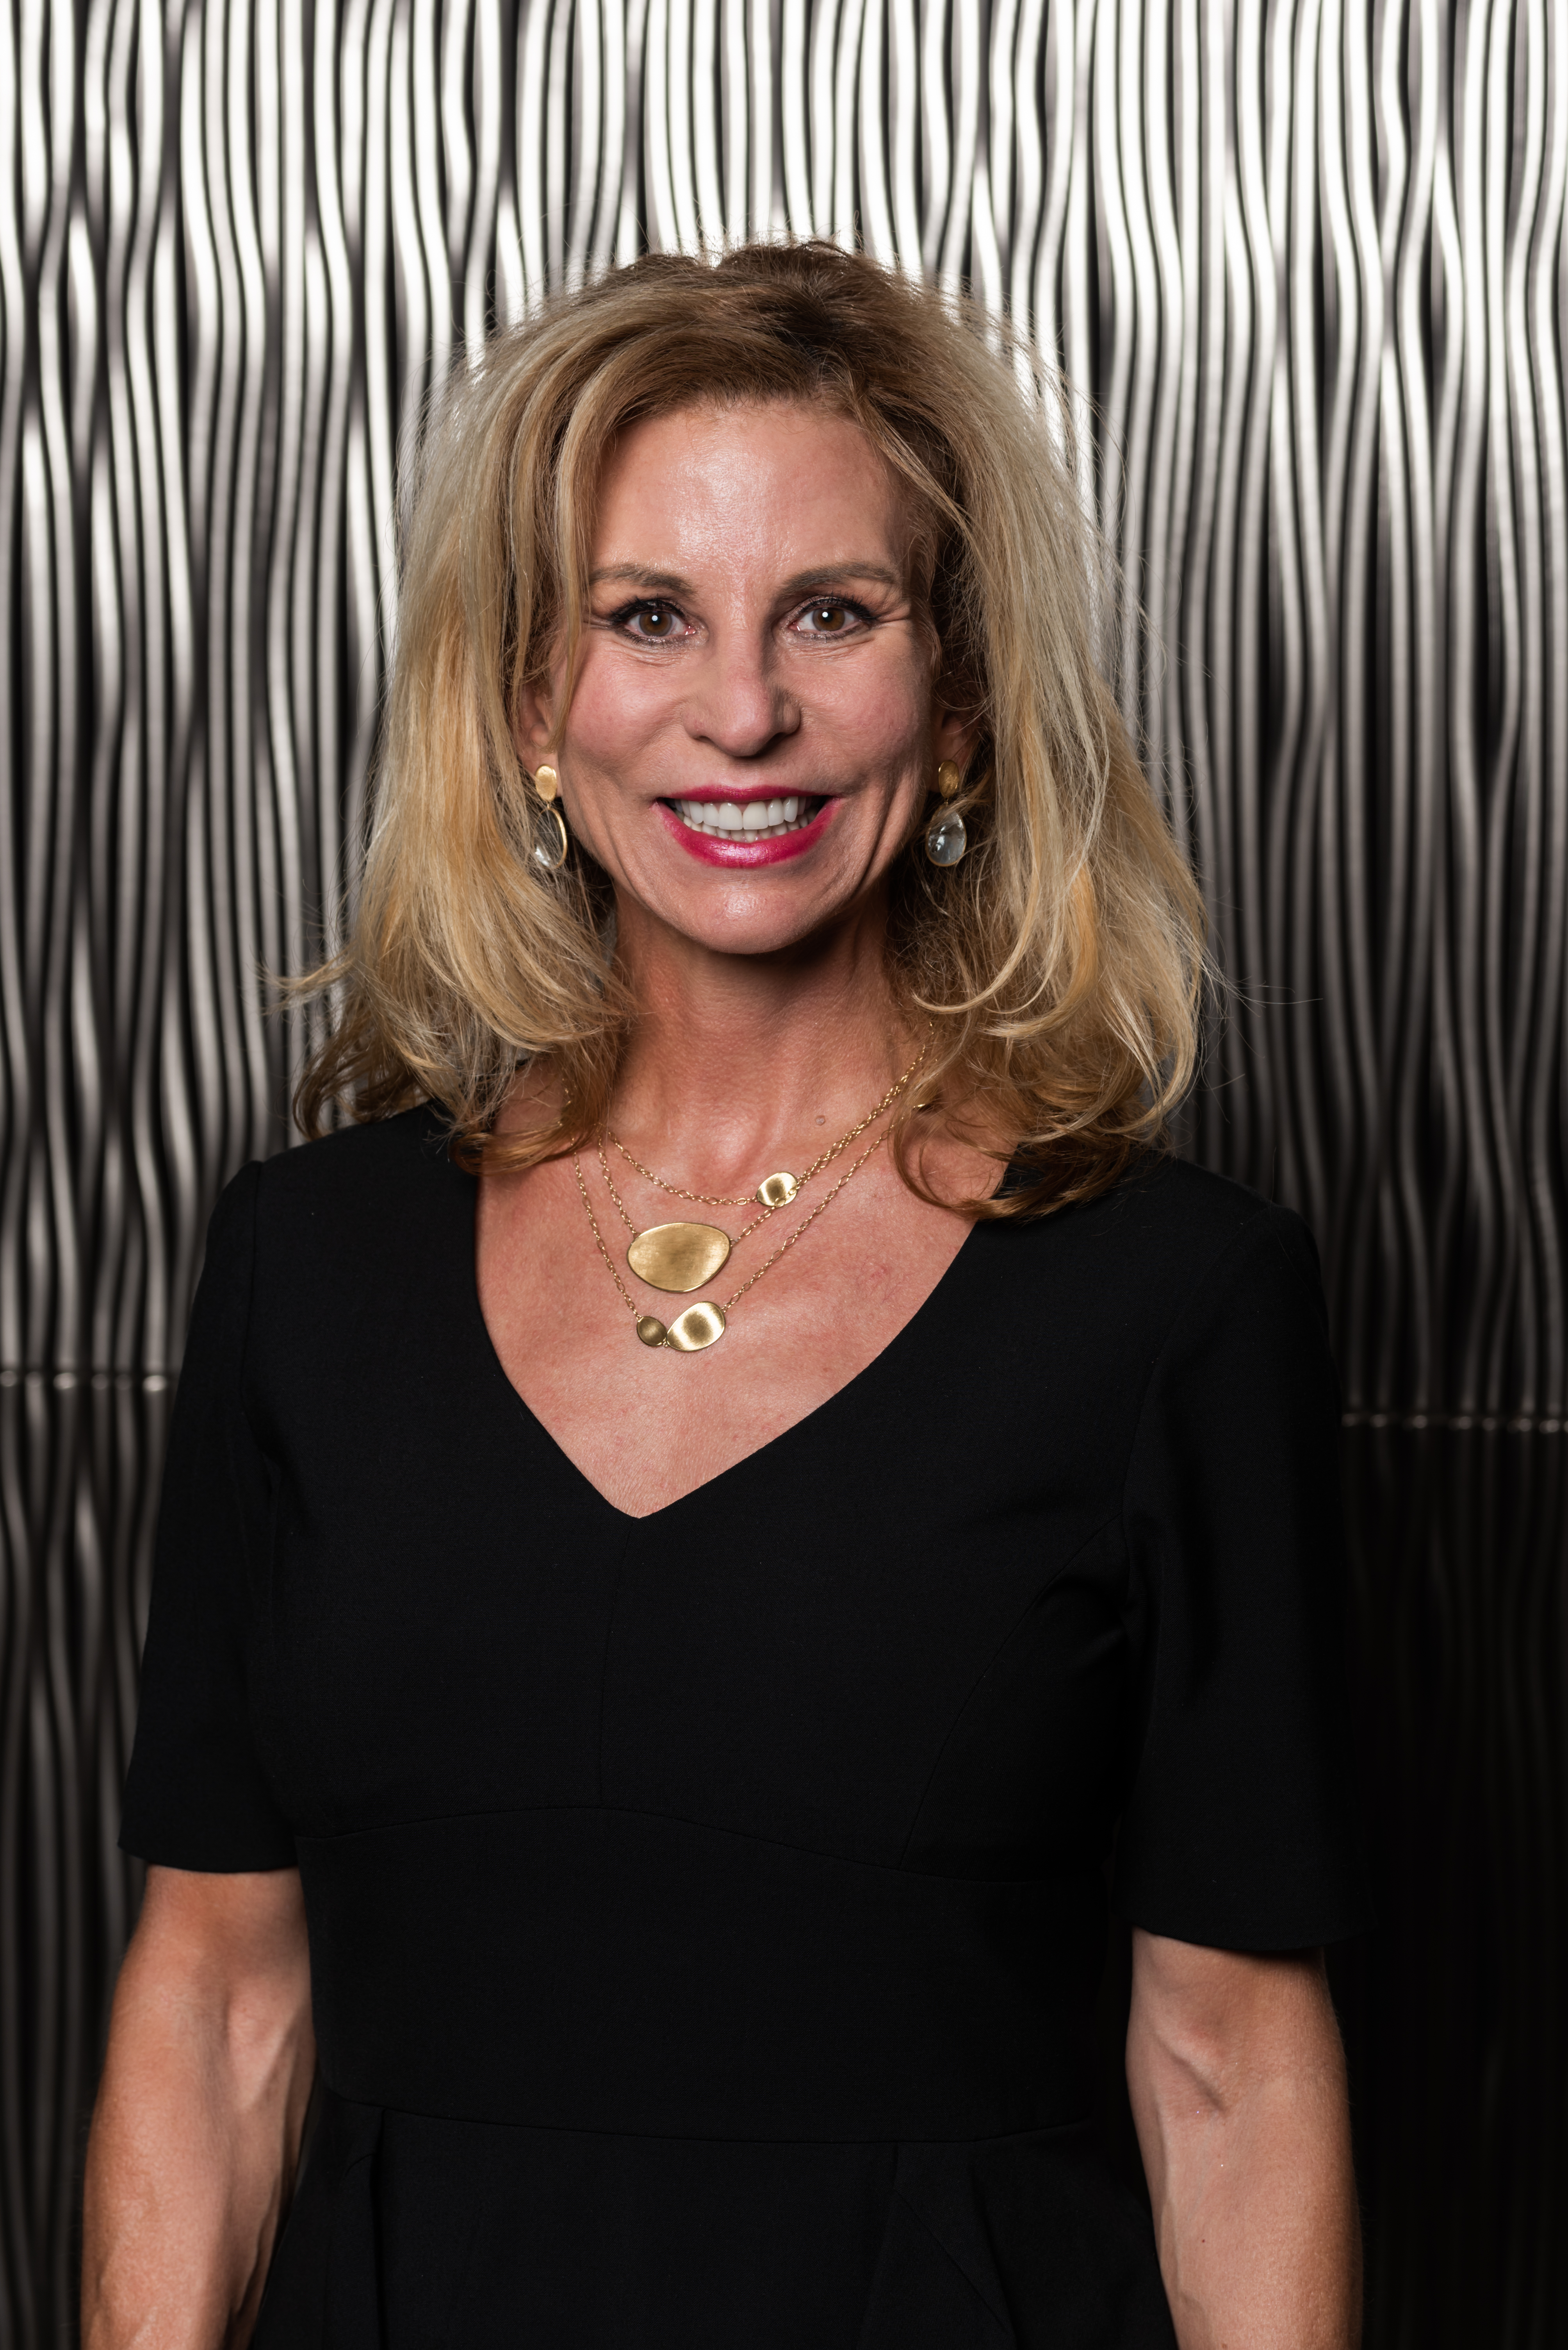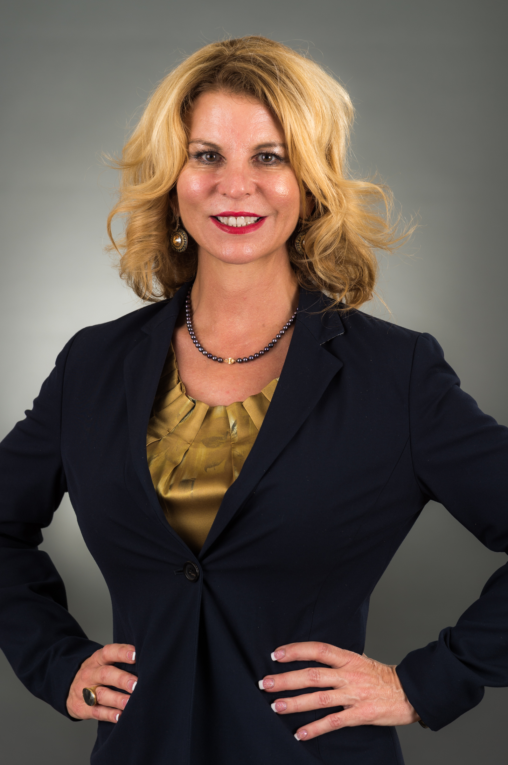
President/CEO
United Way of Broward County
1300 S. Andrews Avenue
Fort Lauderdale, FL 33316
(954) 453-3724
kcannon@unitedwaybroward.org

As a social worker by trade, Kathleen Cannon understands firsthand the impact that non-profits have in the community. As President and CEO of United Way of Broward County she utilizes her talents and undeniable ability to recognize a need and then seek out partners to create long-lasting positive solutions.
Kathleen has been in executive leadership for more than 25 years. Her philosophy is to lead with intention, purpose and to be strategic and goal oriented. She feels motivating and inspiring others to excellence starts with a profound sense of integrity and a positive regard for all stakeholders. Kathleen believes it is important to outline clear expectations which facilitate the accomplishments of desired outcomes. Her experience as a direct service provider and administrator is invaluable in running a well-rounded community organization. These attributes combined with her excellent visionary abilities and sharp business acumen makes her a motivating leader. She was appointed to the Florida Commission on Access to Civil Justice and serves on the Greater Fort Lauderdale Alliance Prosperity Partnership Leadership Team.

Kathleen has received several accolades for her leadership and dedication to ensuring that she is changing all lives for the better including: Women of Distinction Honoree from March of Dimes, Influential Business Women Honoree from South Florida Business Journal and the Women of Excellence Sapphire Award from Cleveland Clinic. Recently she was awarded the Champion of Children Award from HANDY, the Spirit of Justice Award from Legal Aid, the Difference Maker Leadership Award from Extraordinary Women Leading Change Leadership Conference, the Ultimate CEO Award from South Florida Business Journal, a Healthy Mothers Health Babies Outstanding Mother of the Year and was honored with the 2019 Profiles in Leadership Award by Leadership Broward Foundation. In 2021 a recipient of the South Florida Business & Wealth Prestigious Women Awards and The American Society for Public Administration South Florida Chapter 17th Annual Women’s History Month Honoree.

